## Code Camp Day-1

**Program:7**

**MatrixMultiplication:**

**Algorithm:**

**Step 1 :** Start the program

**Step 2 :** Intilize the required variable

**Step 3 :** Enter the First matrix elements

**Step 4 :** Enter the second matrix elements

**Step 5 :** Save the program

**Step 6 :** Multiply the program

**Step 7 :** Run the output

**import** java.util.Scanner;

**public** **class** MatrixMultiplication

{

**public** **static** **void** main(String args[])

{

**int** i, j, k;

**int** arr[][] = **new** **int**[3][3];

**int** arr1[][] = **new** **int**[3][3];

**int** arrm[][]=**new** **int**[3][3];

Scanner scan = **new** Scanner(System.***in***);

System.***out***.print("Enter 3*3 Array1 Elements : ");

**for**(i=0; i<3; i++)

{

**for**(j=0; j<3; j++)

{

arr[i][j] = scan.nextInt();

}

}

System.***out***.print("Enter 3*3 Array2 Elements : ");

**for**(i=0; i<3; i++)

{

**for**(j=0; j<3; j++)

{

arr1[i][j] = scan.nextInt();

}

}

System.***out***.println("Two matrix multiplication is");

**for** (i = 0; i < 3; i++) {

**for** (j = 0; j < 3; j++) {

**for** (k = 0; k < 3; k++) {

arrm[i][j] += arr[i][k] * arr1[k][j];

}

}

}

**for** (i = 0; i < 3; i++) {

**for** (j = 0; j < 3; j++) {

System.***out***.print(arrm[i][j] + " ");

}

System.***out***.print("\n");

}

}

}

**OUTPUT:**

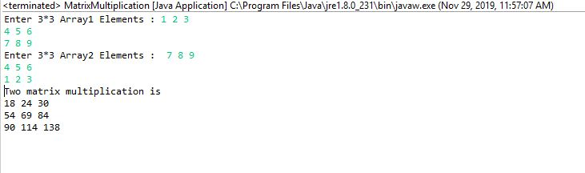

**Program:10**

**It gives compilation error because we need to initialize the variables**

The below code is modified by myself initialized the variables and executed the program.

**AddOfTwoNumbers:**

**import** java.util.Scanner;

**public** **class** AddOfTwoNumbers{

**public** **static** **void** main(String[] args) {

**int** a=0,b=0;

System.***out***.println("Enter two numbers to add: ");

Scanner sc=**new** Scanner(System.***in***);

a=sc.nextInt();

b=sc.nextInt();

System.***out***.println (a);

System.***out***.println (b);

**int** sum=a+b;

System.***out***.println ("The sum is: " +sum);

}

}

**OUTPUT:**

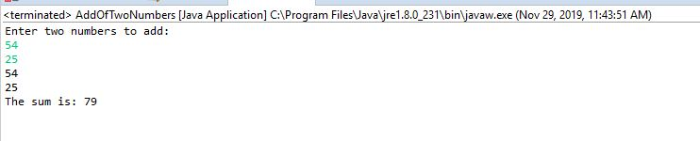

**Program:15**

**In the given code we need to remove the keyword “final”**

**public** **class** Program

{

**private** **static** **final** String ***Program*** = **null**;

**public** **static** **void** main(String[] args)

{

Program t = **new** Program();

*x* = 22;

*y* = 44;

System.***out***.println("Program : " + ***Program***);

System.***out***.println("t.x: " + t.*x*);

System.***out***.println("t.y: " + t.*y*);

System.***out***.println("y: " + *y*);

}

**static** **int** *x* = 11;

**private** **static** **int** *y* = 33;

}

**OUTPUT:**

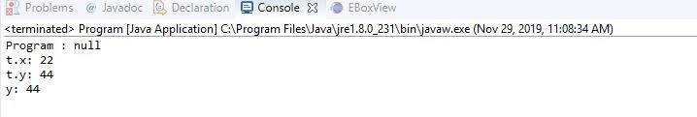

**Program:11**

**public** **class** LinePrinter

{

**public** **static** **void** main (String args[])

{

**char** c = 0x000A;

System.***out***.println(c );

}

}

**Explanation:**

**The given code is without errors.**

**It does not display the outputs.**

**The behaviour of this program is platform independent so it won’t compile on any platform.**

**Program:12**

**public** **class** Shifty

{

**public** **static** **void** main(String[] args)

{

**int** i = 0;

**while** (-1 << i != 0)

i++;

System.***out***.println(i);

}

}

It not printing how many iterations take to exit a loop.

**Program:2**

**public** **class** Employee

{

**int** empId[] = **new** **int**[20];

Employee()

{

}

**public** **void** input(**int**[] empId)

{

**int** temp[] = **new** **int**[20];

**for**(**int** i=0;i<empId.length;i++)

{

**if**(empId[0]<empId[1])

{

temp[0]=empId[0];

empId[0]=empId[1];

empId[1]=empId[2];

}

}

**public** **void** display () {

System.***out***.println(" Employee and sort in desecnding order.");

}

}

**import** java.util.Scanner;

**public** **class** EmployeeMain

{

**public** **static** **void** main(String []args) {

Employee e =**new** Employee();

Scanner sc = **new** Scanner(System.***in***);

System.***out***.println("Employee ids");

**for**(**int** i=0;i<20;i++)

{

id[i]=sc.nextInt(0);

}

}

}

**Program:13**

**Syntax is not correct. We need to change the code. In the code given and they given “Finally” in the Capital letter it should be given in the lower case “finally”**

**I have changed all the mistakes and executed the given code**

**Code:**

**public** **class** HelloWorld

{

**public** **static** **void** main(String args[])

{

**try**

{ System.***out***.println("Hello world");

System.*exit*(0);

}

**finally**

{ System.***out***.println("Goodbye world"); }

}

}

**OUTPUT:**

